Fixed Play Equipment in Schools – Maintaining Free Space and Fall Zones

A key area of the European Standard BS EN1176-2020 Playground Equipment and Surfacing, is the maintenance of free space around the equipment. This is described in two ways by the standard as being Falling Space (also called the Fall Zone) and Free Space.

Falling Space (Fall Zone) is the area around the equipment through which a child falling from the equipment will pass before coming into contact with the impact surface – which, if the height of fall is greater than 600mm, should have impact attenuating properties in line with Standard BS EN1177. This area will be specified by the manufacturer in accordance with the item’s compliance to the Standard, but as a general rule of thumb for items of a size generally in use in schools, this usually extends to a distance of 1.5m at all points from the piece of equipment. However, this should be checked with the manufacturer when purchasing any items of fixed equipment.

Free Space is the three dimensional space around the child when subjected to forced movement (e.g. around a slide) which must be kept free of obstruction from items such as overhanging branches, parts of other items of equipment, bunting etc.

Setting out toys or similar activities within the Falling Space of another item – unless that item is physically disabled at the time - may result in additional injury to a falling child. It would be extremely difficult to defend a claim where a child has been injured whilst using an item of equipment due to the presence of extraneous items within the specified fall zone.
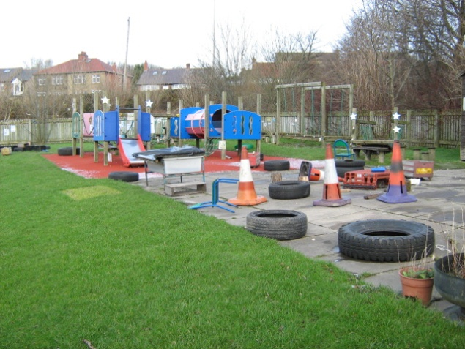
Introducing additional height to a piece of equipment e.g. Chairs/boxes on platform decks, will increase the dimensions of the Falling Space (Fall Zone) and the specification of any required impact attenuating surface. This should not be done under any circumstances.

It is vital that all staff supervising or involved in sessions which include items of fixed play equipment, whether on site or in the local park, are aware of the concepts of free space and falling space and understand why the Standards are in place.

Reviewed January 2022

